**Instructions for Creating an App Engine Service:**

1. Create a new service in App Engine don’t user any existing App Engine Service Account.
2. Please use the “us-central1 (Iowa)” for App Engine creation.
3. Assign the following permissions to the service account:
   * **App Engine Admin**
   * **App Engine Creator**
   * **App Engine Deployer**
   * **Service Account User**
   * **Storage Object Admin**
   * **Storage Admin**
   * **Editor**
4. 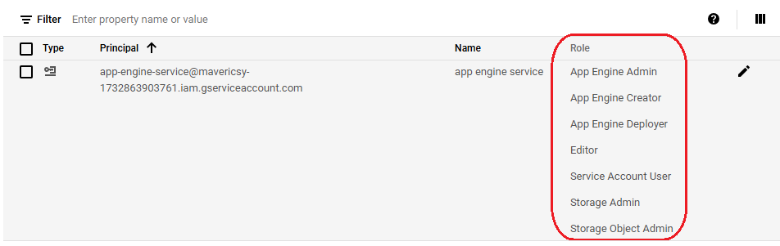
5. App Engine Created
6. 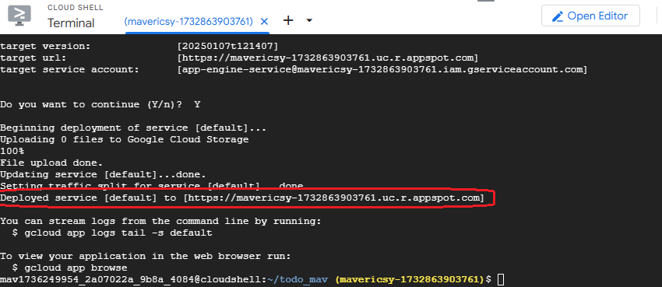

**Instructions for Creating a Cloud Functions:**

1. Create a new service for “Cloud function” don’t user any existing Service Account.
2. Please use the “us-central1 (Iowa)” for “Cloud function”.
3. Assign the following permissions to the service account:
   * Cloud Build Editor
   * Cloud Build Service Agent
   * Cloud Functions Admin
   * Cloud Functions Service Agent
   * Cloud Run Admin
   * Service Account Token Creator
   * Service Account User
   * Service Usage Consumer
4. 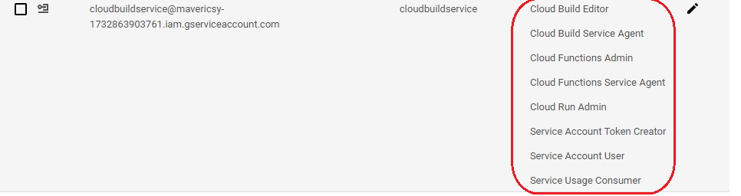
5. Cloud Function Created.
6. A screenshot of a computer

   Description automatically generated